# FocusMe for VBA

## Installation Instructions

### Overview

Microsoft Outlook stores its Macros in a file called “VBAProject.OTM”, located in the directory:  
C:\Users\{WindowsUserName}\AppData\Roaming\Microsoft\Outlook. Outlook uses XML formatted files to customize the Ribbon user interface.

There are three files in the FocusMe Release package (compressed into a zip file);

1. The binary VBA macros – i.e. VBAProject.OTM
2. An XML formatted file that defines the user interface buttons – i.e.   
   20190821 Outlook Customizations (olkexplorer).xml
3. Instructions on how to install the macros (Installation Instructions.pdf)

### Installation – Part One

Install the VBA Macros File

1. Shutdown Outlook
2. Copy the latest zip file to the local desktop, e.g. 20171017 Release.zip
3. Open the Zip file, and select Extract All  
   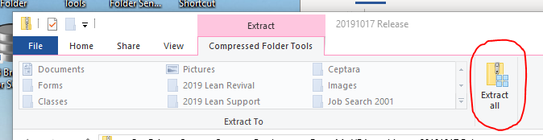
4. From the newly created Folder (generated from the Extract All)
   1. Copy the ‘VBAProject.OTM’ file you just downloaded via the Zip file to the Microsoft Outlook AppData directory - C:\Users\{WindowsUserName}\AppData\Roaming\Microsoft\Outlook
5. Start Outlook
6. When you see the Microsoft Outlook Security Notice, select the ‘Enable Macros’ button – this should automatically start the FME Task List window.

### Installation – Part Two

Install the XML UI file

1. Make sure Outlook is running
2. From the Outlook main window, select the ‘FILE’ tab
3. Select the ‘Options’ menu item, this should start the Outlook Options dialog
4. Select ‘Customize Ribbon’, press the Import/Export button – Import Customization file option
5. In the File Open dialog, select the UI XML file that you extracted in step 5 above, i.e.  
   20190821 Outlook Customizations (olkexplorer).xml
6. Select Open
7. Look for the FocusMe group added to the Home (Mail) tab  
     
   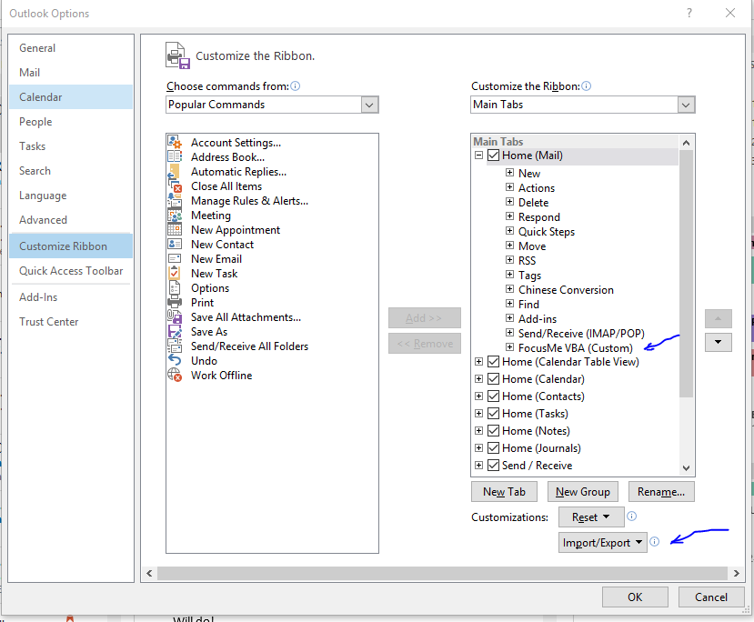
8. This will add a FocusMe VBA, 5D Processing button to the Mail Home tab, and a Timecard button to the Calendar Home tab

### Calendar Home Tab

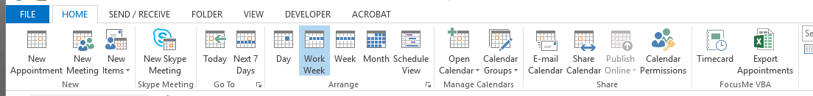

### Mail Home Tab

